Present slideshows

Use Slide Show and Presenter View
With Presenter View, you can see your speaker notes and the next slide in your presentation on your computer, so you can focus on what you want to say, and connect with your audience.
Show your presentation
- Select the Slide Show tab.
- Select an option:
  - From Beginning - starts the presentation from the beginning.
Or, press F5.
  - From Current Slide - starts the presentation from the current slide.
Or, press Shift + F5.
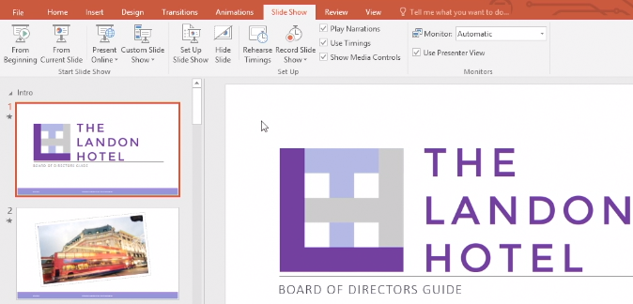
Navigate between slides
- To go to the next slide:
  - Click the mouse.
  - Or, press the Right Arrow key.
- To go back, press the Left Arrow key.
- Press Esc to exit the presentation.
Blank the screen
- Right-click the slide.
- Select Screen > Black Screen or Screen > White Screen.
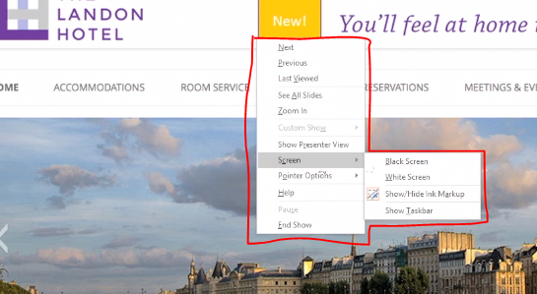
Note: For a keyboard shortcut: Press W to white out your screen, or Press B to black it out instead.
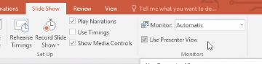
- Click your mouse to go back to the presentation.
Turn on Presenter View with one monitor

Note: Presenter View is typically used with two monitors, but this tutorial covers how to activate and practice with Presenter View when you only have one monitor.
- Select the Slide Show tab.
- Select Use Presenter View, if not already selected.
- From the Monitor drop-down, select the monitor you want to have Presenter View on.
Start Presenter View with one monitor
- Select Slide Show > From Beginning to start the presentation.
- Right-click the slide and select Show Presenter View.
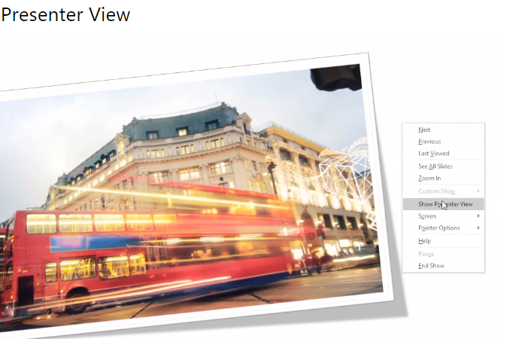
Use Presenter View
- Timer - shows the time you've spent presenting the current slide.
- Current time - shows what time it is.
- Current slide - shows the slide your audience sees, on the left.
- Next slide - shows the next slide in the presentation, on the right.
- Speaker notes - helps you remember what to say about that slide.
- Make the text larger and Make the text smaller - to make the speaker note font larger or smaller.
- Pen and laser pointer tools - to make annotations.
- See all slides - to jump to another slide.
- Zoom into the slide - to zoom in on a slide.
- Black or unblack slide show - to blank the screen while you're talking, to focus the audience on you.
- Left and right arrows - to go to next slide or go back.
- END SLIDE SHOW - to end the slide show.
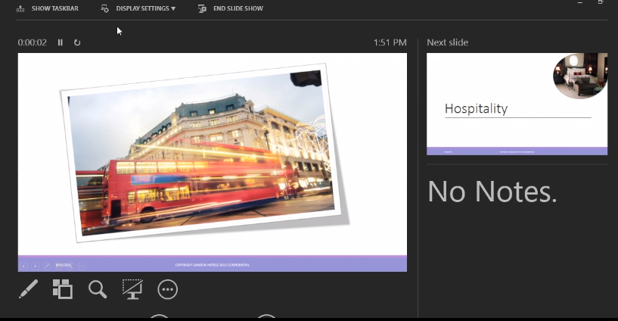

Add speaker notes​
Add speaker notes to help you remember what to say when you present. You can see your notes on your computer, but your audience only sees your slides.
Add speaker notes
- Select Click to add notes below the slide.
If you don't see Click to add notes, select Notes at the bottom of the screen.
- Type your notes.
- Select Notes if you want to hide your speaker notes.
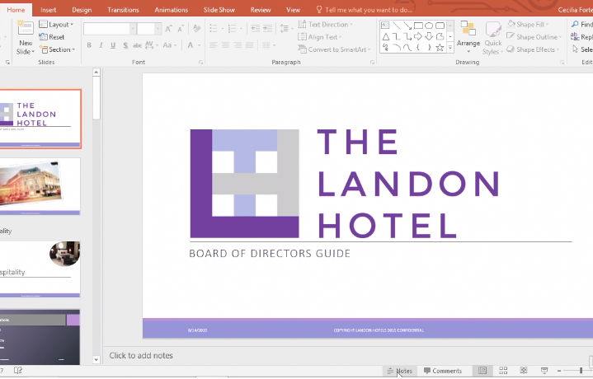

Practice and time your presentation​
PowerPoint has tools to record and time your presentation, so you can practice your timing before you're actually in front of an audience.
Note: If you're an Office 365 subscriber, you have an updated version that looks and works a little different than this video.
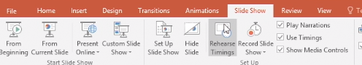
Rehearse your presentation
- Select Slide Show > Rehearse Timings.

- Start speaking.
PowerPoint records your rehearsal.
- Click the mouse or press the Right Arrow key to go to the next slide.
- If you have a video, select Play to play it, to see how long your presentation is with the video.
- Select the Pause icon if you want to pause recording. Select Resume Recording to resume.
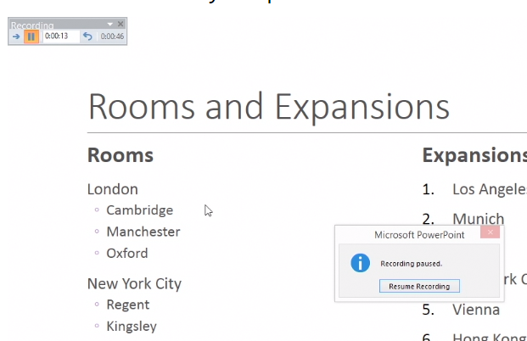
Note: The number to the right of the Pause icon is the time for the current slide. The time to the right of that is the time for the whole presentation.
- Press Esc to stop recording and exit the presentation.
- Select Yes to save the slide timings, or No if you don't want to save them.
View the timings
- Select View > Slide Sorter.
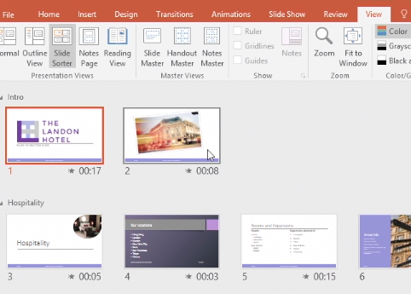
- See how long you're spending on each slide and:
  - Break up slides that take too long.
  - Cut or combine slides that are too short.

Print presentations​
In PowerPoint, you can print your slides, your speaker notes, and create handouts for your audience.
Print your presentation
- Select the File > Print.
- For Printer, select the printer you want to print to.
- For Settings, select the options you want:
  - Slides - from the drop-down, choose to print all slides, selected slides, or the current slide. Or, in the Slides: box, type which slide numbers to print, separated by a comma.
  - Print Layout - choose to print just the slides, just the speaker notes, an outline, or handouts.
  - Collated - choose if you want them collated or uncollated.
  - Color - choose if you want color, grayscale, or pure black and white.
  - Edit Header & Footer - select to edit the header and footer before printing.
- For Copies, select how many copies you want to print.
- Select Print.
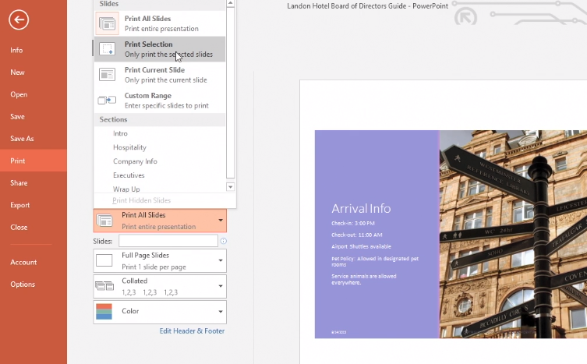

Record presentations
You can record your presentation, slide and animation timings, and more. Here's how to record, play, and clear recordings.
Note: If you're an Office 365 subscriber, you have an updated version that looks and works a little different than this video.
Record your presentation
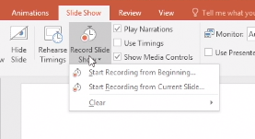
- Select Slide Show > Record Slide Show.
- From the drop-down, select an option:
  - Start Recording from the Beginning
  - Start Recording from Current Slide

- If prompted, select what you want to record:
  - Slide and animation timings
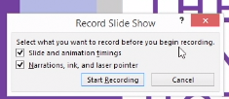
  - Narrations, ink, and laser pointer

- Select Start Recording.
Pause and resume recording
- Select Pause to pause while recording.
- Select Resume Recording to resume recording.
Stop recording
- Press Esc.
You will see a speaker icon on the lower right of the slides that were recorded.
Play recording
- Select the speaker icon on the slide.
- Select Play.

To adjust the volume, hover over the speaker icon and adjust the slider to the volume you want.
Clear timing and narration
- Select Slide Show > Record Slide Show.
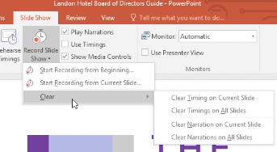
- From the drop-down, select Clear and select an option:
  - Clear Timing on Current Slide
  - Clear Timings on All Slides
  - Clear Narration on Current Slide
  - Clear Narrations on All Slides

